Study visit report (SV3) – Latvia, November 2017

In November 2017 I had a chance to participate in my second study visit, this time in Latvia. Although educational systems are different in various countries, the teachers often face similar problems, because the main purpose of education is the same everywhere. That is why, the study visits are such a good way to find some solutions. They give the participants the opportunity to observe, share and discuss and as a result bring something new and useful to one’s work practice.
Before coming to Latvia I thought of an issue that I would like to analyze more deeply. As a teacher I often face students who complain, because they have to do their homework. So I decided to focus on this matter. I went to Latvia with a plan to observe how is this handled there. I prepared a few questions for which I was willing to find the answers. Those were:
- Do students get homework in Latvia?
- How often do they get homework?
- How much homework do they get?
- How is homework checked and assessed?
- What feedback do students get?
During the visit in Latvian schools I had an opportunity to discuss this subject with some of the teachers and some of the students. I found out that the situation in Latvia is very similar to the one in Poland. That inspired me to collect some more data after coming back to Cracow.
I conveyed a survey among students from 4th – 7th grade (aged 10 – 13) and their parents. They were asked to fill in a questionnaire which consisted of 10 questions. The students answered the questions about themselves, the parents answered the same questions about their children. Then the answers were collected and analyzed. The results are presented below:

Question 1:
How much time do you spend doing your homework every day? | How much time does your child spend doing his/her homework every day?
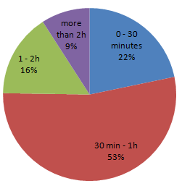 | 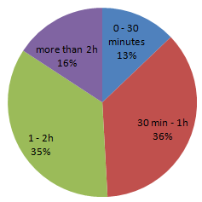
Question 2:
Do you get homework every day? | Does your child get homework every day?
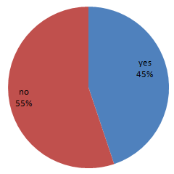 | 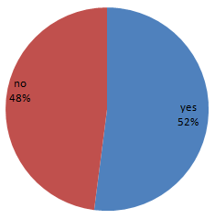
Question 3:
Your homework is: | Your child’s homework is:
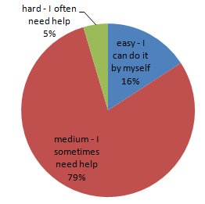 | 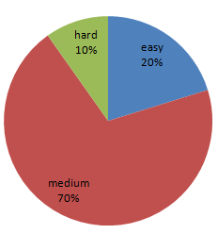
Question 4:
Does anyone help you with your homework? | Does anyone help your child with his/her homework?
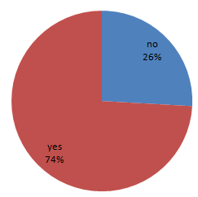 | 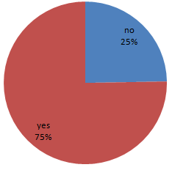
Question 5:
Do teachers check if you have done your homework? | Do teachers check if the students have done their homework?
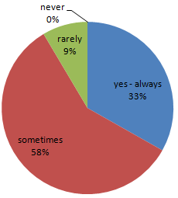 | 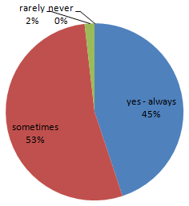
Question 6:
Do you receive information if the homework has been done correctly? | Does your child receive information if he/she has done his/her homework correctly?
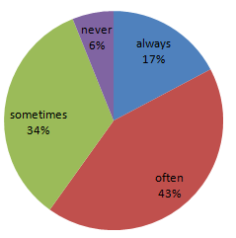 | 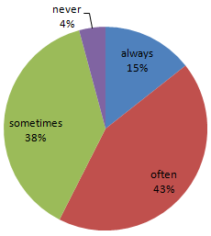
Question 7:
Do you think that doing your homework helps you revise and consolidate your knowledge from the lesson? | Do you think that doing their homework helps your child consolidate their knowledge from the lesson?
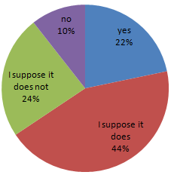 | 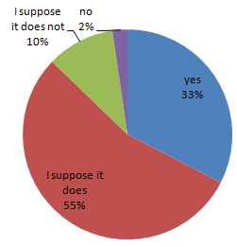
Question 8:
Do you think that doing your homework helps you prepare for the next lesson? | Do you think that doing their homework helps your child prepare for the next lesson?
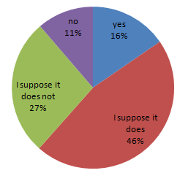 | 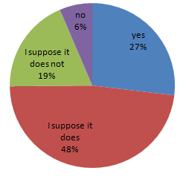

Question 9:
Do you think that homework is unnecessary, it is just a waste of time? | Do you think that homework is unnecessary, it is just a waste of time?
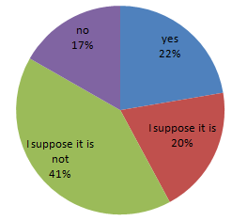 | 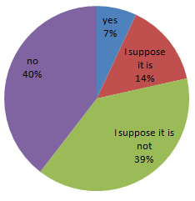
Question 10:
Do you want to be given homework? | Do you want your child to be given homework?
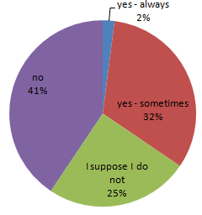 | 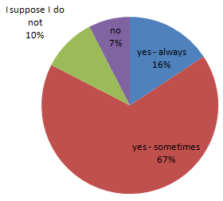

The survey provided information about some main factors concerning homework. First of them was the amount of time spent by students on doing their homework. The majority of students spend no more than 2 hours a day on their homework. The interesting thing is that some parents believe that their children spend more time doing schoolwork than they actually do.
The second factor was the difficulty level of students’ homework. For most of them, activities that they have to do at home are not very easy but also not too hard. Those exercises put them in the position where they cannot do homework automatically and they have to focus, but on the other hand the activities are not discouraging because of being too hard to complete.
The survey also showed that most students and parents believe that homework is useful. Both students and parent agreed that by doing homework students revise and consolidate their knowledge which results in an increase in their schoolwork. There is a visible difference between students and their parents opinion when it comes to the question of giving homework. Although students know that homework can be beneficial for them, they would rather not be given any homework. 66% of students answered that they do not want any homework, while 83% of parents said that they would like their children to get some homework.
Doing this small action research gave me an overall view on the subject of homework. As a result I decided to try to make some changes. Now, the students are given homework only once a week and they have a week to hand it in. They were given some freedom in choosing exercises that they do. They are obliged to do a set number of exercises but it is their choice which ones. The exercises have different difficulty levels. In this way, even the students with difficulties can complete some exercises. That motivates them and give them the sense of achievement. The homework is checked and each student is given feedback – what they did correctly, what they have to improve etc.
As my next steps I want to continue with the implemented changes and check in the nearest future what effect do they have on the students’ learning process. I also plan to move further with the subject of homework and focus more on the preferred form of homework.
Marta Lenda, School no. 36, Cracow

