Angielska Liga Zadaniowa 2017/2018 styczeń

Podpisz obrazki.
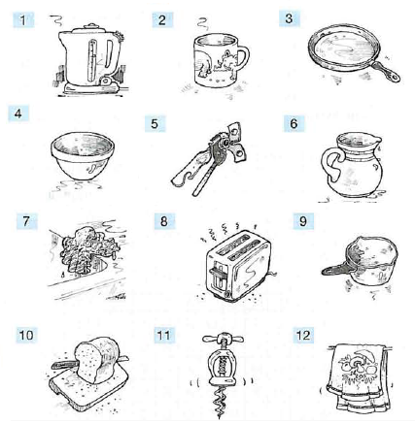
- ……………………
- ……………………
- ……………………
- …………………….
- …………………….
- …………………….
- ……………………..
- ……………………..
- ……………………..
- ………………
- ……………….
- ……………….

Znajdź 12 ukrytych narodowości.
S | C | O | T | T | I | S | H | V | S
A | D | F | P | F | R | E | N | C | H
U | M | U | V | O | S | G | T | L | B
S | Z | E | T | M | H | Y | V | U | R
T | W | N | R | C | O | P | P | S | I
R | A | Q | X | I | H | T | Y | C | T
I | H | Y | Z | R | C | I | B | H | I
A | M | E | X | I | C | A | N | I | S
N | E | I | K | E | D | N | N | N | H
I | N | D | I | A | N | B | P | E | M
G | F | A | S | P | A | N | I | S | H
R | U | S | S | I | A | N | O | E | N

- ……………………………… 7. …………………………………….
- ……………………………… 8. …………………………………….
- ………………………………… 9. …………………………………….
- ………………………………… 10. …………………………………..
- ………………………………… 11. ……………………………………
- ………………………………… 12. …………………………………….

Uzupełnij tekst. W każdą lukę wpisz tylko jedno słowo.
If you don’t know what a word ……………………, try to ………………………. the meaning, or ……………………. up the word in your dictionary.
All foreign speakers ……………………. an accent, but that doesn’t matter. To make your pronunciation better, listen to English speakers and try to imitate them. Don’t worry if you ………………….. mistakes – that’s normal!
It’s often useful to ……………………….. words from one language to the other, but it’s best when you can start to think in the new language.

