Angielska Liga Zadaniowa styczeń 2017

Zadanie 1
Uzupełnij krzyżówkę liczbą mnogą podanych słów.
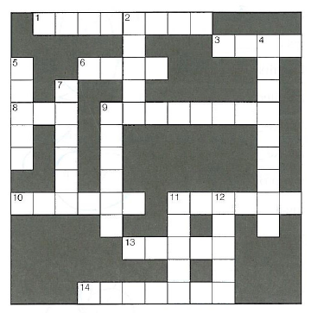

Across: Down:
1. potato 10. kiss 2. tooth 9. city
3. mouse 11. baby 4. country 11. box
6. foot 13. taxi 5. woman 12. bus
8. man 14. glass 7. knife
9. child

Zadanie 2
Nazwij części twarzy zaznaczone na obrazku.
Zadanie 3
Przeczytaj tekst i zdecyduj, czy poniższe zdania są prawdziwe (T), czy fałszywe (F).

Hi! I’m Dina. I’m 14 and I love sport. My friends from school do gymnastics, go dancing or play basketball, but I do boxing. It is not very popular among teenage girls and my mum isn’t very happy about it. She says that it isn’t for girls but I really like it. Luckily, my dad doesn’t mind. I go to the gym and meet my coach Mr Dawson on Tuesdays and Fridays from four to six. Mr Dawson is very strict, but I like him. He say my diet, relaxation and fitness are important, so I get up at six o’clock every day and go running. After a shower and good breakfast, I walk to school. I have lunch at school and I get home from school at about half past two. I’ve only got two free afternoons to meet friends in the week because on Mondays I go to Spanish lessons. I go to bed at about eleven pm.

- Dina hasn’t got any friends. T / F
- Her parents like her sport. T / F
- Dina goes to the gym in the afternoon. T / F
- She trains with her coach for four hours. T / F
- Boxing is Dina’s only after-school activity. T / F
- She has some free time on weekdays. T / F
- Dina doesn’t go to bed early. T / F

