1. Uzupełnij tekst odpowiednimi słowami. W każdą lukę wpisz literę A, B, C lub D.
What do you like doing best (1) ……… your spare time? My cousin Paul likes going (2) ……… in the country and (3) ……… photos. Sometimes he (4) ……… with his friends, and they (5) ……… at the park or at the beach. They always (6) ……… a good time. His brother Chris isn’t (7) ……… on walking. He spends most of the (8) ……… at home. His (9) ……… activity is watching television. He can’t (10) ……… noisy people.
- A) for B) when C) in D) at
- A) for walks B) walks C) a walk D) to walk
- A) making B) having C) taking D) doing
- A) travels B) gets up C) sees D) goes out
- A) enjoy B) hobby C) go D) have fun
- A) have B) make C) do D) like
- A) interested B) out C) decided D) keen
- A) other B) time C) people D) money
- A) favourite B) happy C) brother D) always
- A) like B) stand C) be D) have
2. Rozwiąż krzyżówkę.
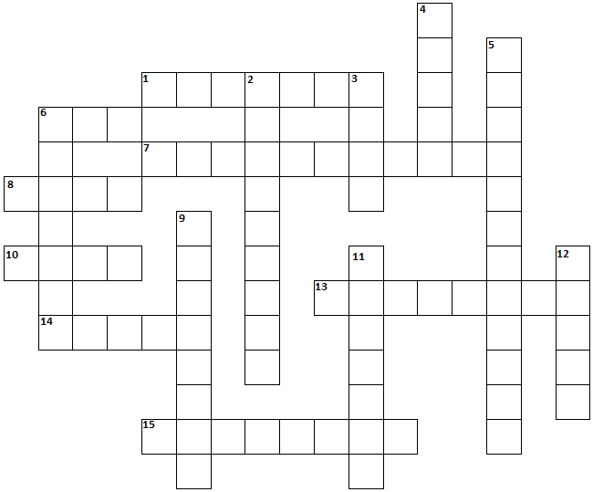
Across:  1 The things that you put in the bin.  6 The object that you use to open a locked door.  7 A place where you can buy food.  8 A green traffic light means “go”, a red light means ………………….. .  10 A thing that you wear on your foot.  13 Are you ready for your exams? How much …………………. have you done?  14 A person who works in a hospital.  15 When people are angry and shout, they have an ………………………………. . | Down:  2 The meal that you eat in the morning.  3 The part of your body where you wear a hat.  4 Something that you eat between meals when you are hungry.  5 The relative who is married to your sister.  6 The place where you usually cook a meal.  9 The exercises that your teacher gives you to do after your lessons.  11 The ceremony that people have when they get married.  12 The object that you use to cut food.

3. Znajdź przeciwieństwa podanych przymiotników i wpisz je w odpowiednie miejsca.
C | L | O | R | O | M | B | S | O | F | B
A | D | E | W | L | S | H | O | R | L | A
W | S | A | D | D | L | O | F | E | O | D
P | S | E | M | P | T | Y | T | O | W | P
N | E | W | W | O | D | S | O | N | E | S
S | A | S | T | O | R | A | S | L | O | W
M | B | H | E | R | Y | H | I | B | L | H
A | D | O | W | C | O | L | D | A | S | I
L | E | R | S | R | E | T | H | I | N | R
L | W | T | W | C | L | O | S | E | D | E
P | O | O | R | W | O | S | T | E | F | W

Adjective | Opposite | Adjective | Opposite
good  fat  big  tall  full  young  open  rich | .................................  ……………………………..  ……………………………..  ……………………………..  ……………………………..  ……………………………..  ……………………………..  …………………………….. | hot  old  happy  fast  high  wet  hard | ……………………………..  ……………………………..  ……………………………..  ……………………………..  ……………………………..  ……………………………..  ……………………………..

