- Napisz słownie liczby. Z zaznaczonych pól powstanie hasło.
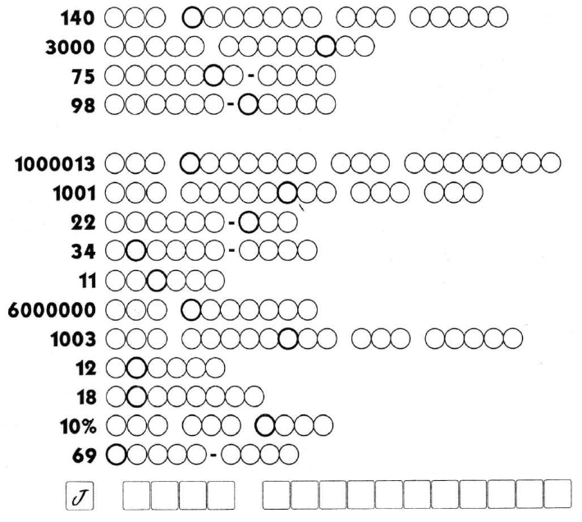
2. W każdą lukę wpisz jedno słowo. Formy skrócone uznawane są za jedno słowo.
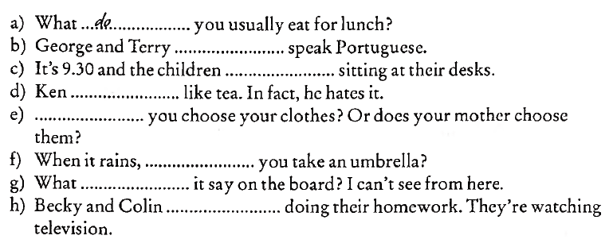
3. Przeczytaj tekst i odpowiedz na pytania (pełnymi zdaniami).
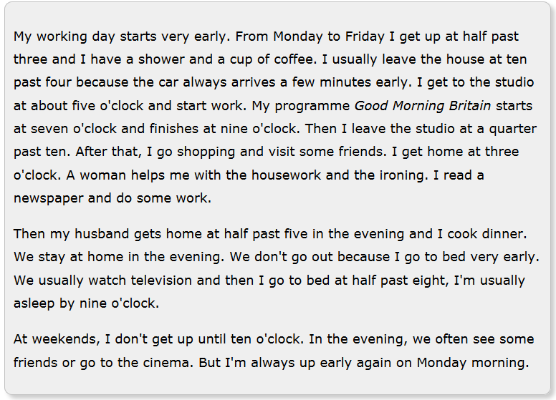1. What time does Cynthia get up during the week?
2. How does Cynthia get to the studio in the morning?
3. What time does she arrive at the studio?
4. What time does the TV show begin?
5. How long does “Good Morning Britain” last?
6. What time does Cynthia get home after finishing at the studio?
7. What time does her husband arrive home?
8. Do Cynthia and her husband go out in the evening?
9. What time does Cynthia go to bed?
10. Does Cynthia stay in bed longer at the weekend?

